|  |  |  |  |  |  |
| --- | --- | --- | --- | --- | --- |
| Date | December 6, 2022 | | | Tester Name | Syed Shahabuddin |
| Environment | Penfax - Test | | | Login used |  |
| Operating System | Windows | Version: | Update: | | |
| Software Used | Edge | Version: | Update: | | |
| Select Software | Version: | Update: | | |
| Release version | 22.4.1 | | | | |
| Title | 26.02 | | | | |
| Test Type | Regression | | | | |
| Test Scenario | Receiving Scheduled Monthly payment, and PEPP steps rollover on the same day (specified order withdrawal instructions) | | | | |
|  |  | | | | |
| Expected Results | Both the scheduled withdrawal, the interfund and the DAI change will all process on the same day. The funds withdrawal will still be specified between PEPP steps and the specialty fund. | | | | |
| Pass/Fail | Pass | | | JIRA# | N/A |

Made note on testing spreadsheet to test the year end processes last to ensure this issue doesn’t occur in the future.

(see test case 23.01 for info to find member)

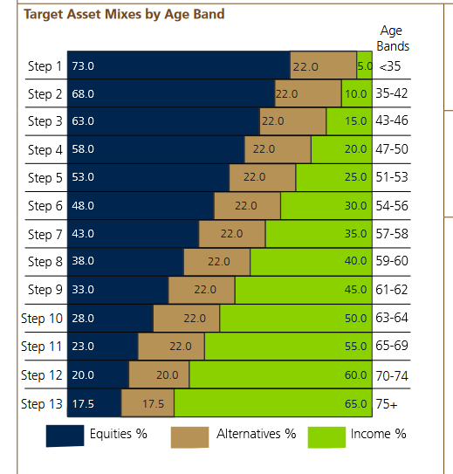

SID: 241701 – Scheduled, specified order (only one fund)

Ruanne Diederichs

Changed birthdate to Oct 6, 1957 (65) should move to step 11 overnight

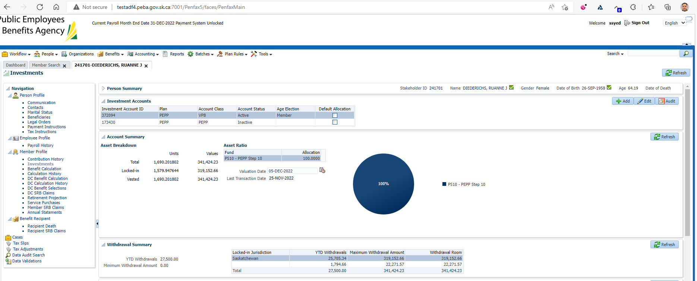

Next Day:

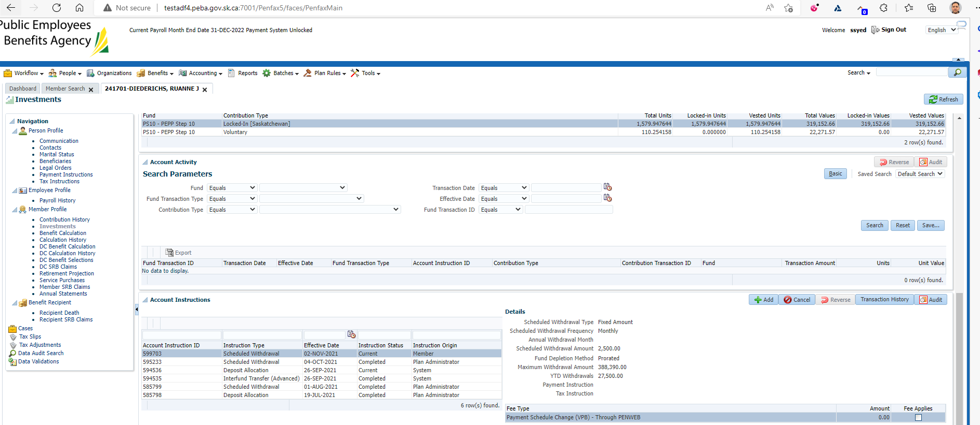

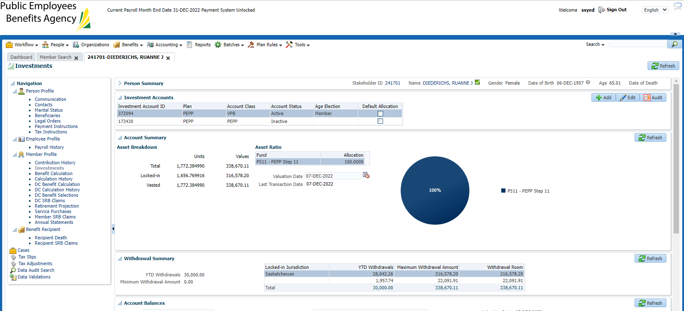

Funds transferred to PEPP Step 11 successfully.

SID: 102031 Scheduled, fixed, specified

Jim Purdy

Updated birthdate to oct 6 1952

Should roll to step 12 overnight

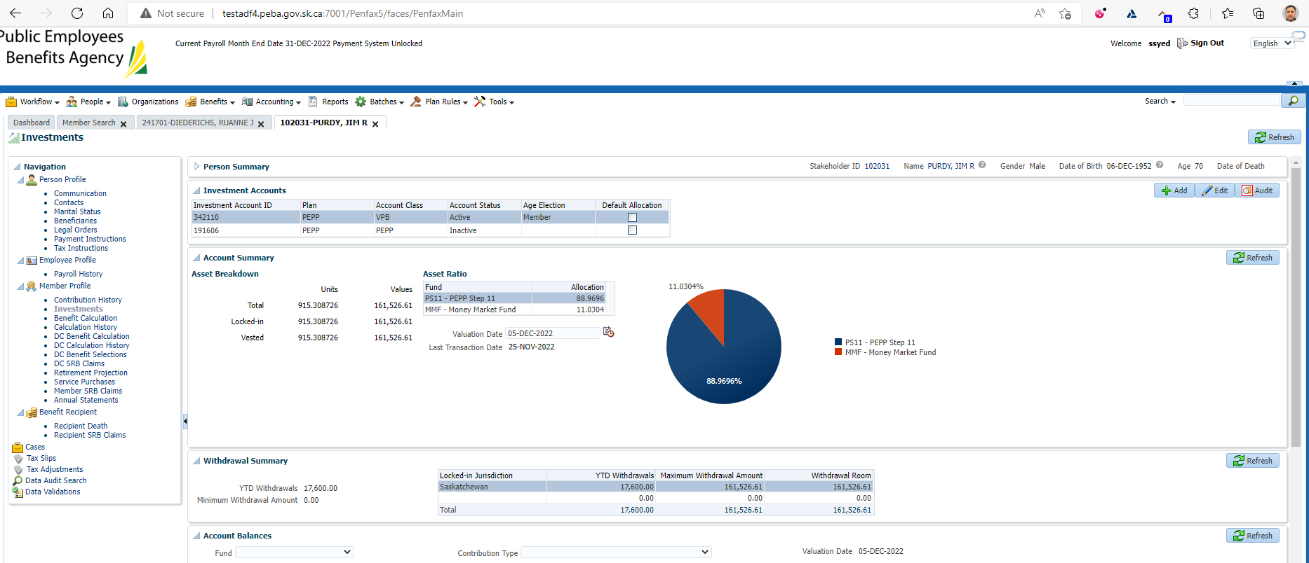

New Scheduled withdrawal added & pending interfund:

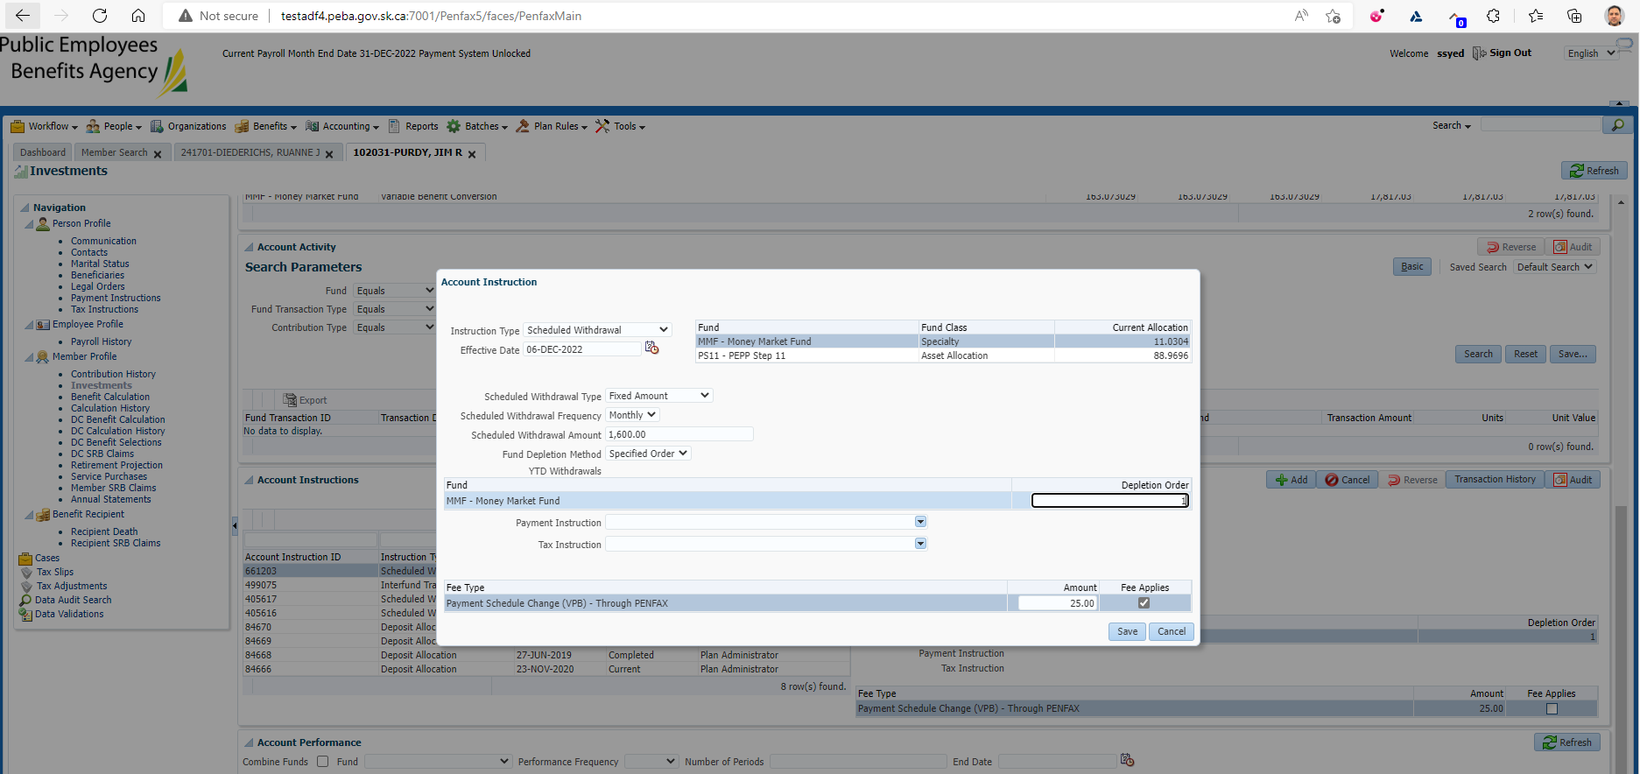

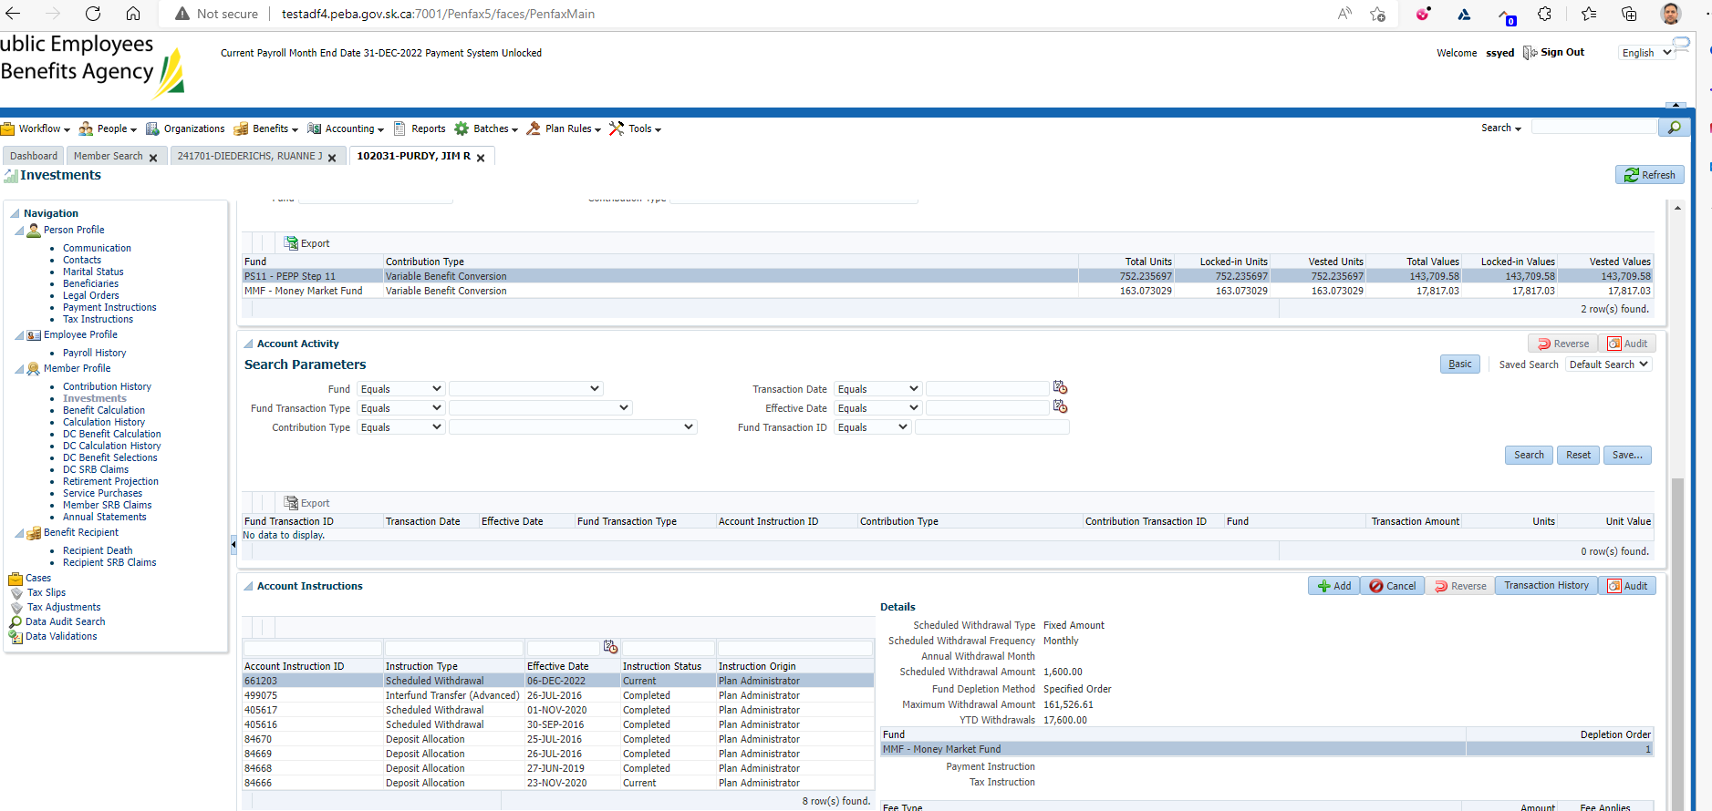

Funds for December payroll came out of appropriate fund

(December did not, and was prorated, specified order instruction was only added on October 5th after Dec payroll was run)

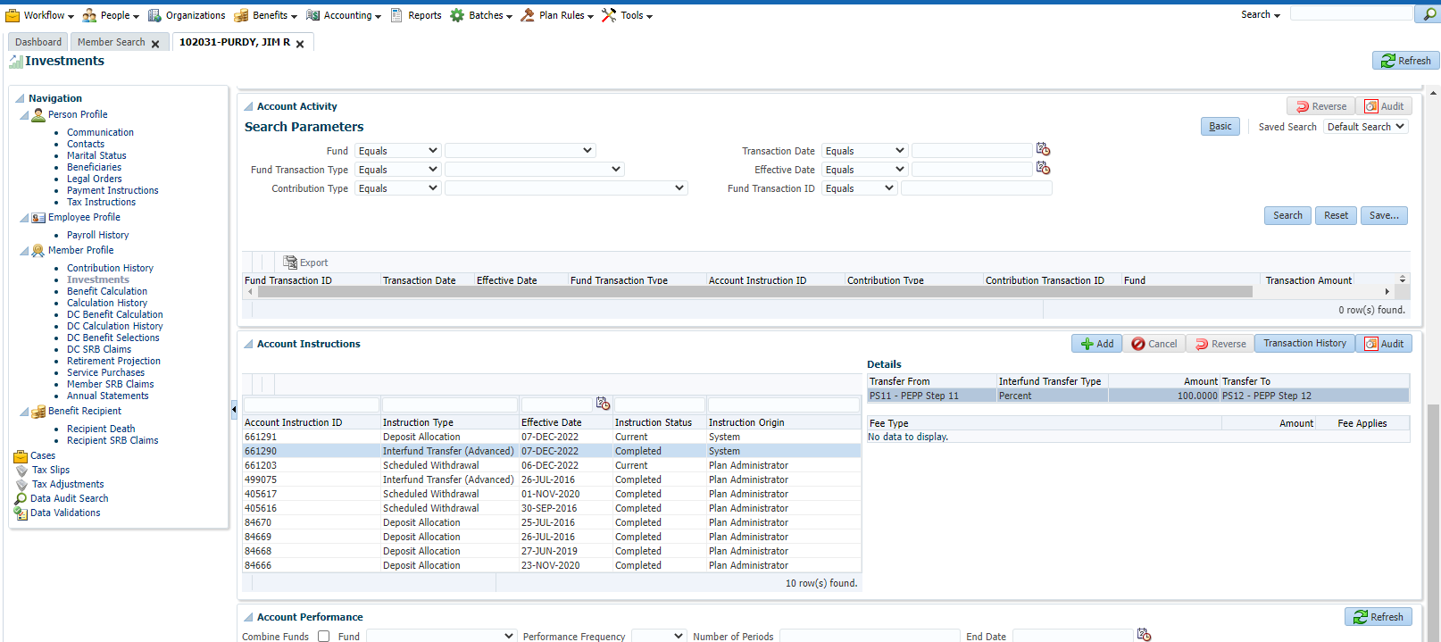

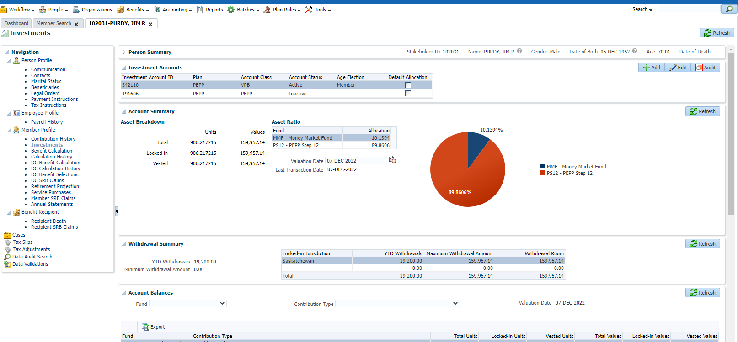

SID: 187447 – scheduled, fixed, specified

Wanda Hildebrand

Updated birthdate to oct 6, 1959

Should roll to step 10 overnight.

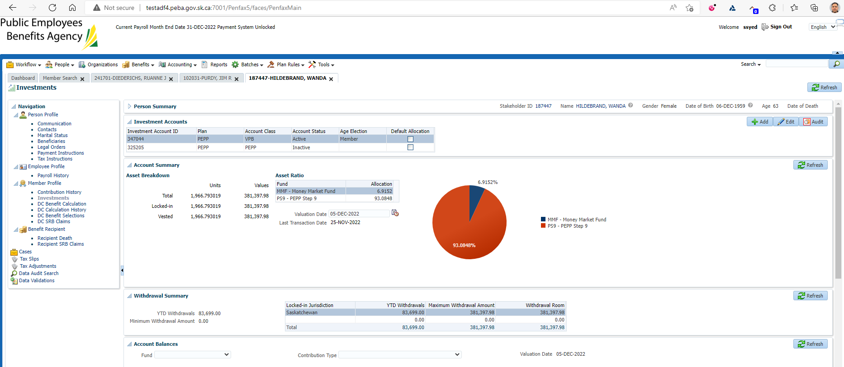

New Scheduled Withdrawal created & specified order matches previous scheduled withdrawl:

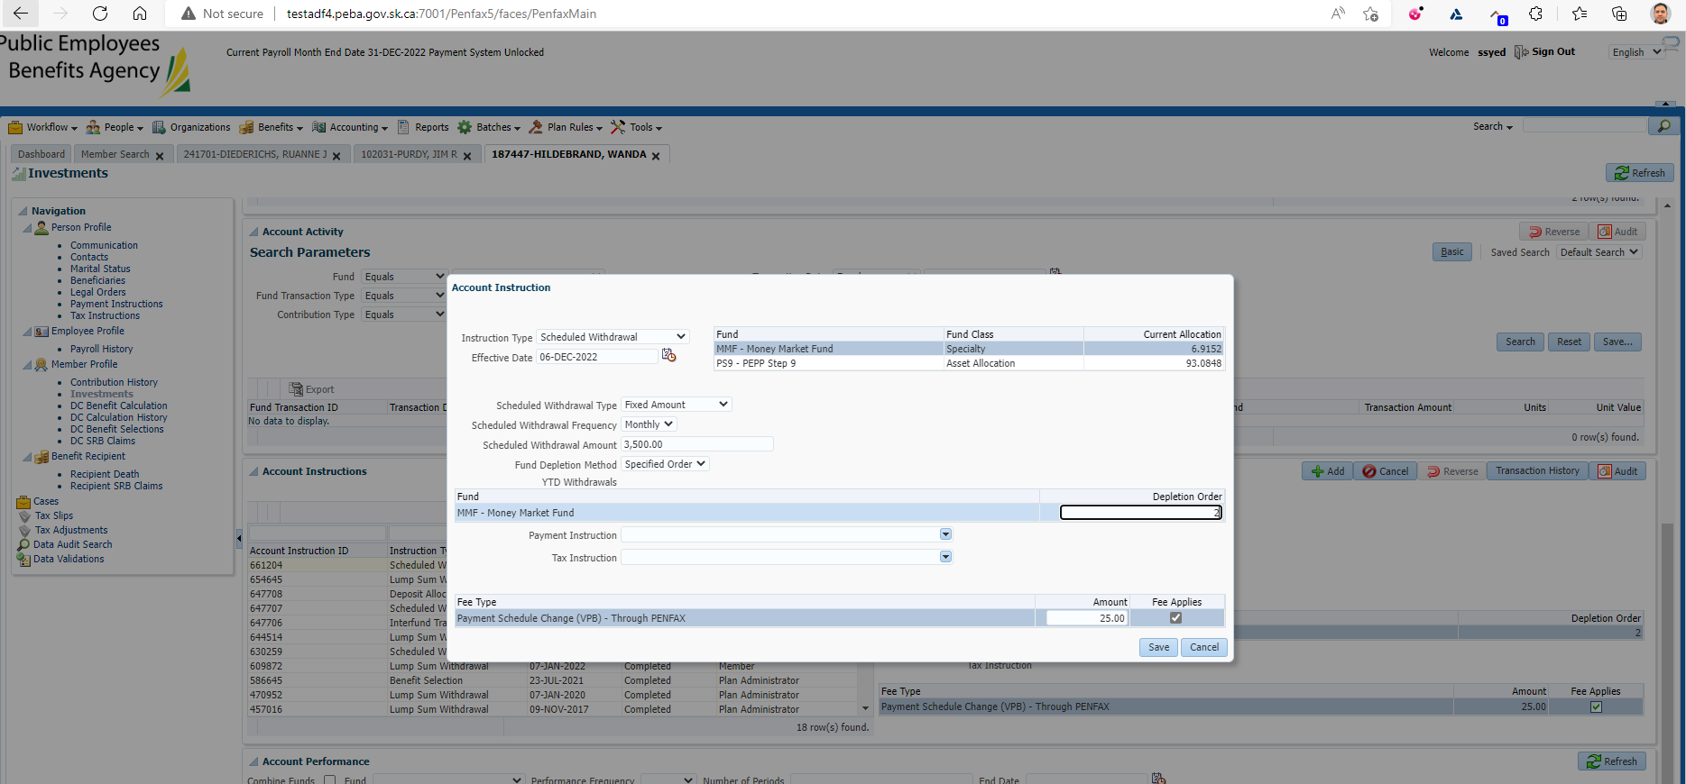

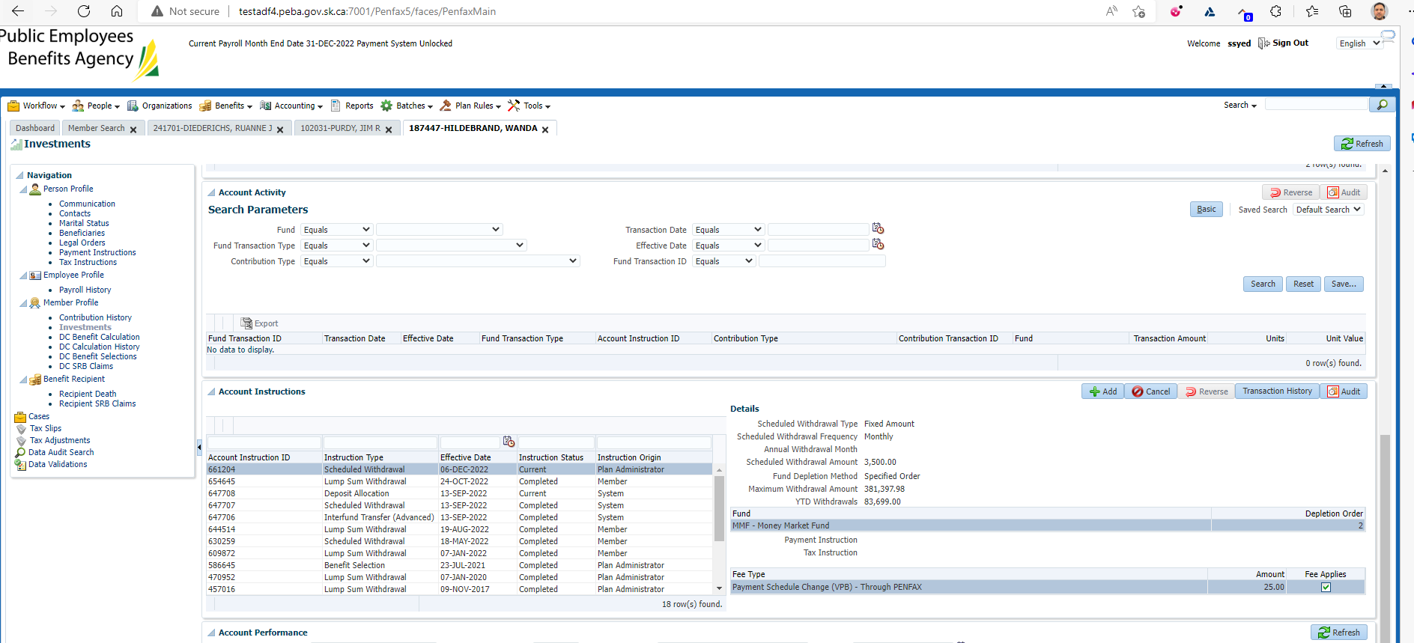

Confirmed that scheduled withdrawal was taken from PEPP steps:

